# Answer Sheet: Risk Management Part

MCAS mis-activation on the faulty design

# 截屏2024-04-12 14.10.08

# wpsoffice

MCAS mis-activation on Aggressive Design

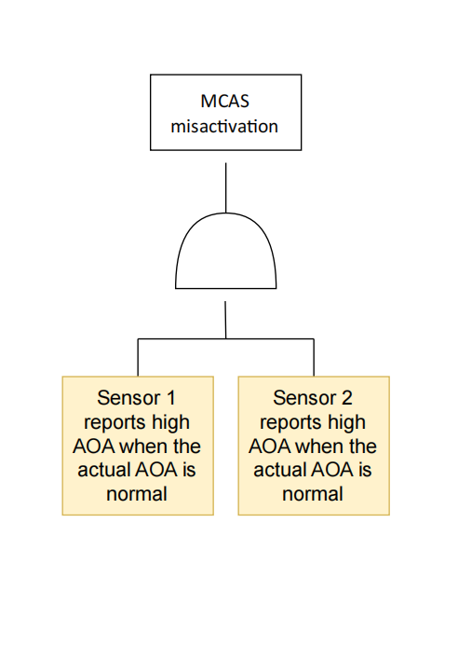



MCAS fails to activate when needed on the faulty design

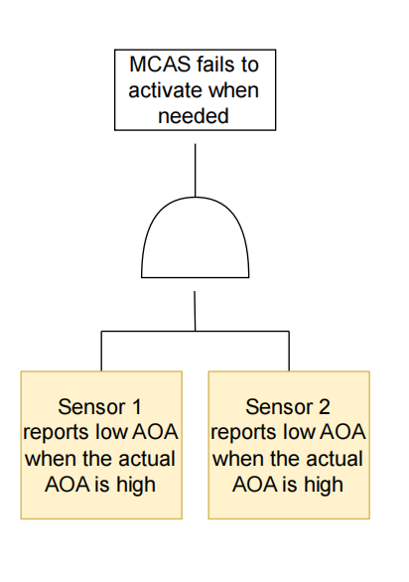



MCAS fails to activate when needed on Aggressive Design

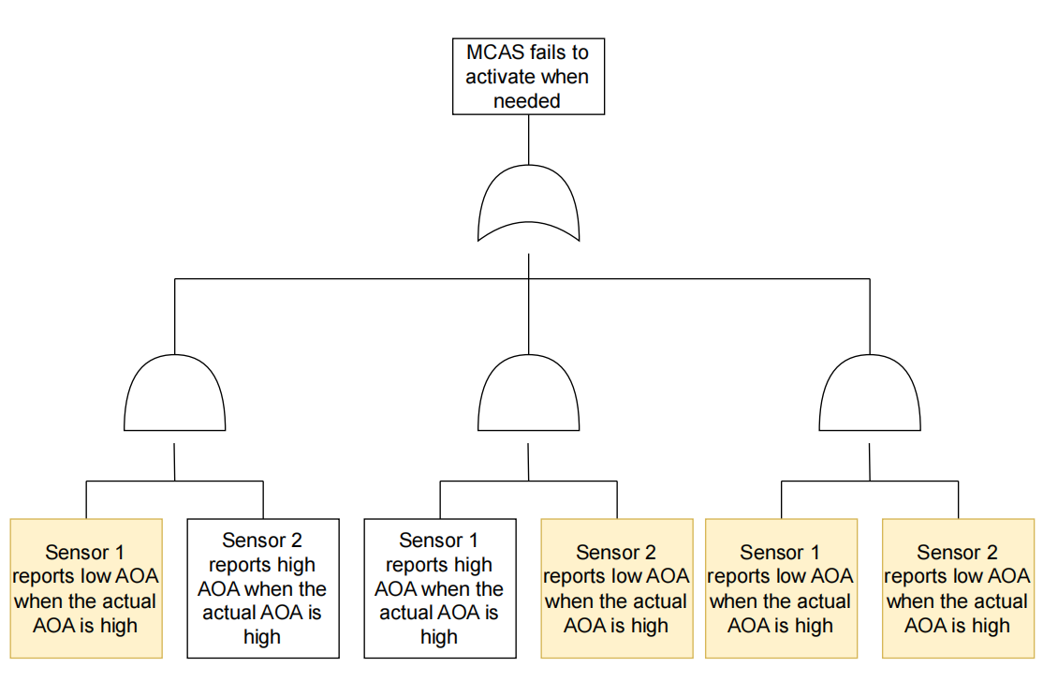



MCAS mis-activation on the 2/3 design

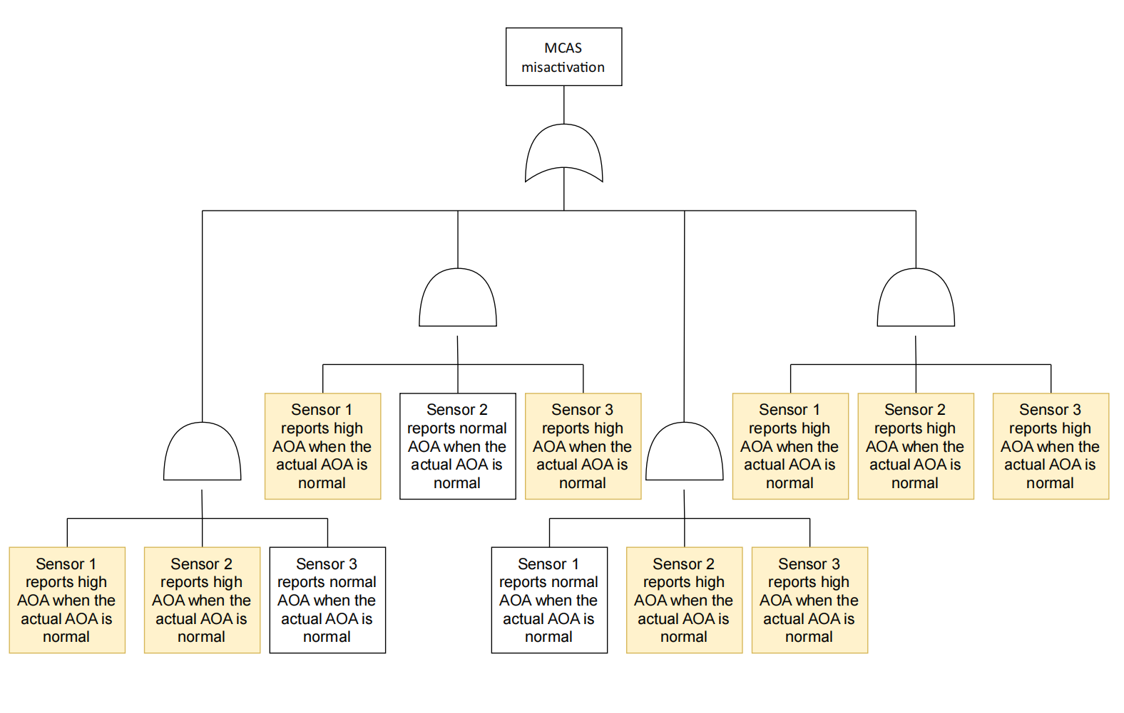



MCAS fails to activate when needed on 2/3 Design

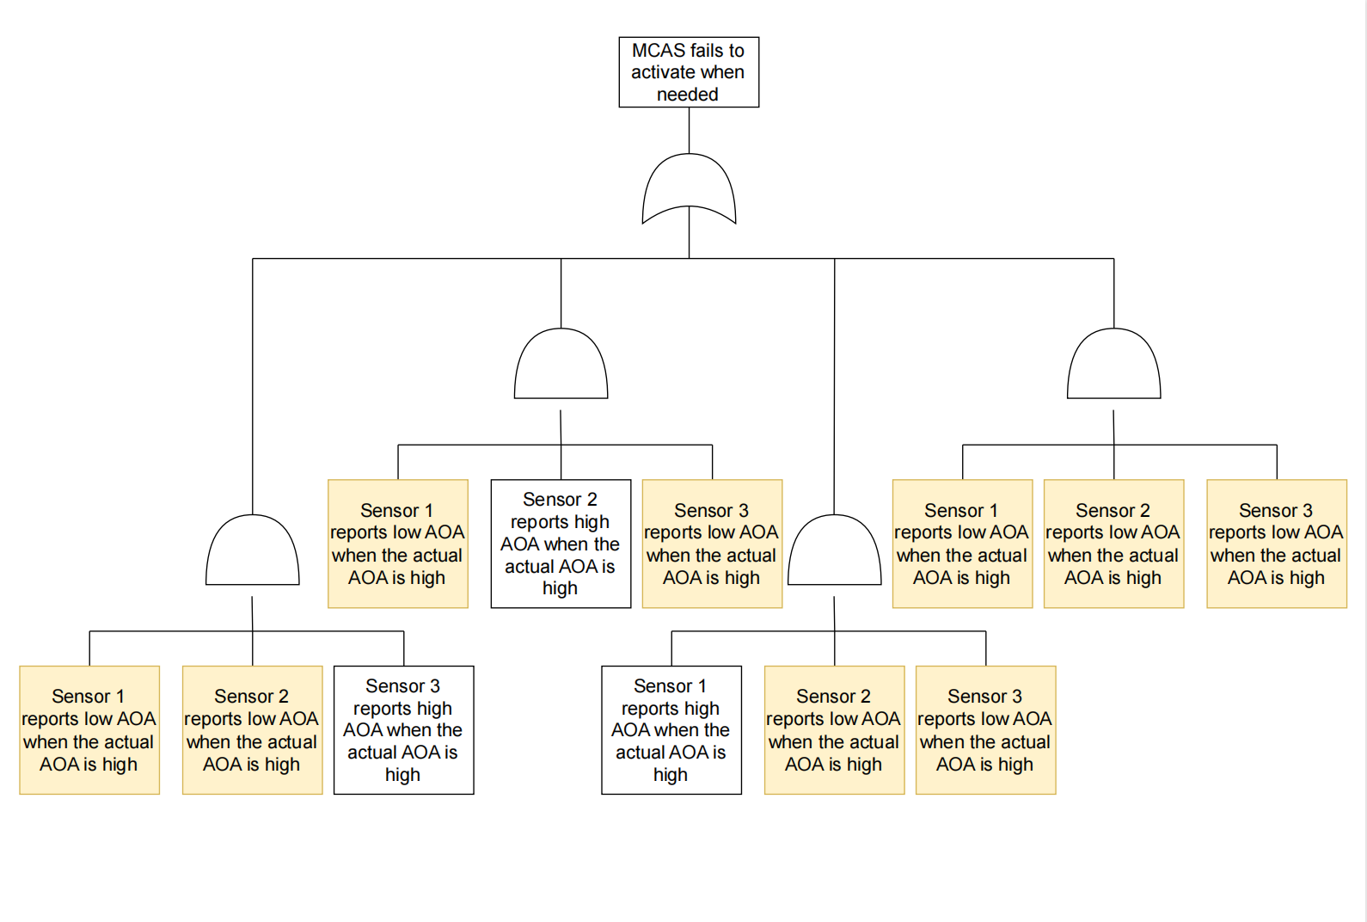



2/3 design is an overall better design because it both reduces the probability of mis-activation and activation failure below 1.00%.

Compared to faulty design, 2/3 design does not increase the probability of activation failure very much but sharply decrease the probability of mis-activation.

Compared to aggressive design, 2/3 design does not increase the probability of mis-activation. very much but sharply decrease the probability of activation failure.

|  |  |  |  |
| --- | --- | --- | --- |
|  | **Faulty** | **Aggressive** | **2/3** |
| MCAS mis-activation | 1.97% | 0.01% | 0.0295% |
| MCAS fails to activate when needed | 0.01% | 1.97% | 0.0295% |

# Answer Sheet: UPPAAL Part

Required files: greedy.xml, greedy.xtr, polite.xml, and polite.xtr (if necessary)

1. a:

knife1_fork1: there is 1 knife and 1 fork on the table

knife0_fork1: there is no knife and 1 fork on the table

knife1_fork0 : there is 1 knife and no fork on the table

knife0_fork0: there is no knife and no fork on the table

1. b:

knife0_fork1

1. c:

knife0_fork0

2-a: Model File: greedy.xml

paste the picture of your template of greedy customer here

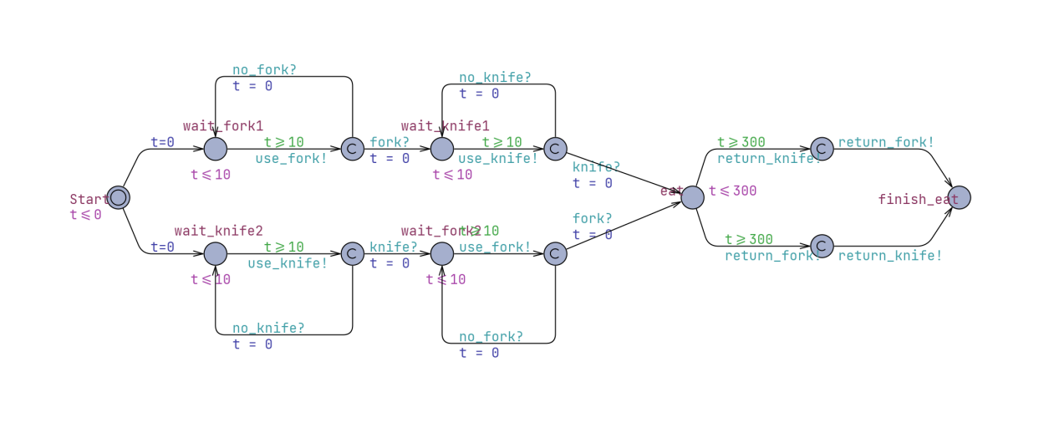

2-b:

Query:

A[] gclk > 700 imply GreedyCustomer1.finish_eat or GreedyCustomer2.finish_eat

Validation Result:

截屏2024-04-12 19.56.43

Counter Example (Trace File): greedy.xtr

3-a: Model File: polite.xml

paste the picture of your template of polite customer here

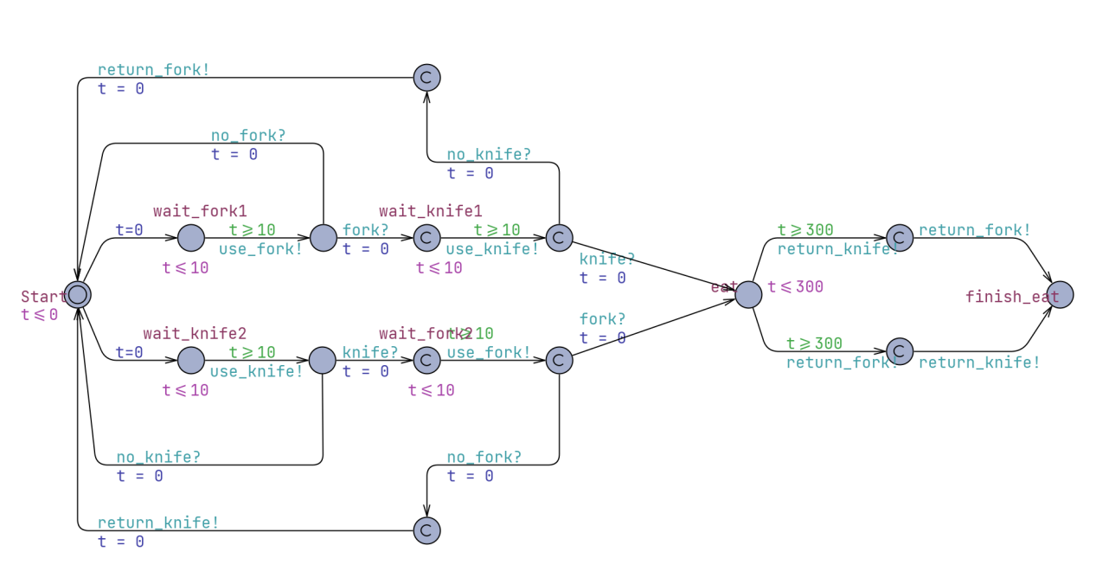

3-b:

Query:

A[] gclk == 700 imply PoliteCustomer1.finish_eat and PoliteCustomer2.finish_eat

Validation Result:

截屏2024-04-12 22.19.17

Counter example (Trace File): polite.xtr (if necessary)